CONTENT BEYOND SYLLABUS
IMPLEMENTATION OF REMOTE COMMAND EXECUTION(RCE)
AIM:
To implement Remote Command Execution(RCE).
ALGORITHM:
CLIENT SIDE
- Establish a connection between the Client and Server.
Socket client=new Socket("127.0.0.1",6555);
- Create instances for input and output streams.
Print Stream ps=new Print Stream(client.getOutputStream());
- BufferedReaderbr=newBufferedReader(newInputStreamReader(System.in));
- Enter the command in Client Window.
Send themessage to its output
str=br.readLine();
ps.println(str);
SERVER SIDE
- Accept the connection request by the client.
ServerSocket server=new ServerSocket(6555);
Sockets=server.accept();
- GettheIPaddressfromitsinputstream.
BufferedReaderbr1=newBufferedReader(newInputStreamReader(s.getInputStream()));
ip=br1.readLine();
- During runtime execute the process
Runtime r=Runtime.getRuntime();
Process p=r.exec(str);
CLIENT PROGRAM:
import java.io.*;
import java.net.*;
class clientRCE
{
public static void main(String args[]) throws IOException
{
try
{
String str;Socket client=new Socket("127.0.0.1",6555);
PrintStream ps=new PrintStream(client.getOutputStream());
BufferedReader br=new BufferedReader(new InputStreamReader(System.in));
System.out.println("\t\t\t\tCLIENT WINDOW\n\n\t\tEnterTheCommand:");
str=br.readLine();
ps.println(str);
}
catch(IOException e)
{
System.out.println("Error"+e); }
}
}
SERVER PROGRAM:
import java.io.*;
import java.net.*;
classserverRCE
{
public static void main(String args[]) throws IOException
{
try
{
String str;
ServerSocket server=new ServerSocket(6555);
Socket s=server.accept();
BufferedReader br=new BufferedReader(new InputStreamReader(s.getInputStream()));
str=br.readLine();
Runtime r=Runtime.getRuntime();
Process p=r.exec(str);
}
catch(IOException e)
{
System.out.println("Error"+e);
}
}
}

OUTPUT:
SERVER WINDOW:
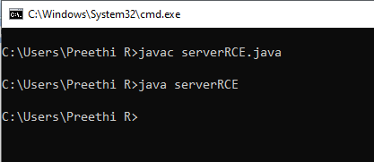
CLIENT WINDOW:
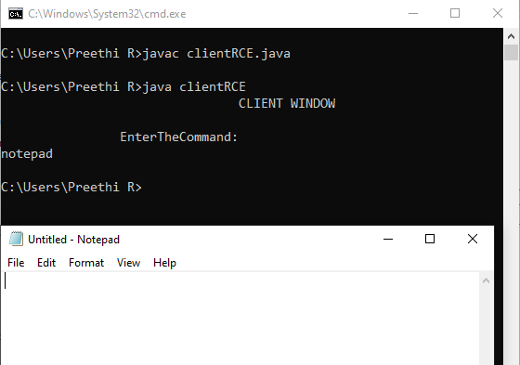
RESULT:
Thus the implementation RCE is done & executed successfully.

